





PLM 2025-35
India PLM Steering Group

Project Proposal

Version 2.0

16 October 2026

India has evolved into a potential global powerhouse of PLM, but that potential has not been realised. Perhaps due to global economics, India has a kind of secondary position - somehow seen more as a resource to be called upon rather than a source of world leadership.

Yet the whole concept of 'Offshore', where PLM is subcontracted and delivered for 'Onshore', is contrary to all the aims and principles that we work to. There should be no difference between the calibre of practitioner and the application of PLM skills in any part of the world.

Now we can do something about it. We can reverse the polarity and move India to the top of the pyramid.

The mechanism that can achieve this is the PLM 2025-35 Project, and the driving force is the India PLM Steering Group.

This document is a Proposal for the PLM Interest Group to manage and support the India PLM Steering Group over the twelve-month project timeframe, and explains how organisations of all types can participate.

CONTENTS
This Proposal is set out under the following headings:-

1 WHY AN INDIA PLM STEERING GROUP? 3
1.1 Potential 3
1.2 Demand 3
1.3 Industry Leadership 3
1.4 Round Table Structure 4
1.5 Global PLM Context 4
2 IMPACTING THE MARKET 5
3 PLM 2025-35 STRUCTURE 6
4 METHODOLOGY 7
5 PLMIG SUPPORT 8
5.1 Management 8
5.2 Tools 8
5.3 Workshops 8
5.4 Documentation 8
5.5 Coordination 8
6 ADMINISTRATION 9

WHY AN INDIA PLM STEERING GROUP?

Potential
PLM in India is equal to PLM anywhere else in the world in terms of scope, remit, manufacturing base and potential capability. India now accounts for nearly half of the global ER&D sourcing market. GCCs have matured to own core product development, systems engineering, and PLM architecture for global OEMs. India’s own manufacturing enterprises are upgrading into full enterprise PLM, Digital Twin, and MBSE environments.

There is a surge in engagement driven by two major market trends: the expansion of Global Capability Centres (GCCs) and accelerated domestic PLM adoption.

The intellectual power is already there, and it needs some kind of driving force to pull it all together.

The kind of things that are missing are standardised PLM governance, process maturity, and formal body of knowledge frameworks - structured platforms to shape standards and develop right-first-time methods.

Demand
A recent LinkedIn article on PLM in India unleashed a tidal wave of support. According to LinkedIn, over 10,700 different PLM practitioners read it. 54% are from companies with 10,000+ employees, which is a significant portion of India’s PLM infrastructure.

A rough calculation suggests this may represent about 1800 of the biggest PLM-oriented companies in India, all interested in the possibility of an India PLM Steering Group. This is more than enough demand to generate the industry leadership that is needed.

Industry Leadership
Achieving widespread PLM change in India requires leadership and authority:- leadership to define what needs to be done, and authority so that CEOs will feel happy to act. The concepts of PLM are not well understood at Board level, and to many CEOs, investing in PLM feels like ‘taking a chance’.

Blueprints published by a Steering Group comprising some of India’s leading companies will have the credibility that CEOs will respect, and the continually-evolving message will be reinforced by success stories as the Project progresses.

Round Table Structure
Participation in the Steering Group is by company, because it is the company names that CEOs will respect. The Steering Group is a Round Table, with every voice equal. Vendors, integrators, consultancies, academics and the advisory world are also welcome. .

The general brief of the Steering Group is to remove the boundaries to PLM thought. With a Round Table format and participants from all parts of the spectrum, it can cover business and enterprise issues, adoption barriers, new advances and industry direction.

It is difficult to overstate the power of a well-set-up Steering Group. Coming from a range of backgrounds, its Members start as strangers but soon gel together and become a team. Users, vendors and advisers find themselves working with each other in a way that happens nowhere else.

That is exactly what will happen with the India PLM Steering Group, and what gives it its power to change the direction of PLM. The PLMIG provides the working material, but the Steering Group members provide the guidance and the authority. Collectively, over the 12-month timeframe, they combine their expertise to shape the new Vision for India.

Global PLM Context
The question could be asked why there should be a Steering Group for India, when PLM is a global subject. The PLM 2025-35 Project is set up to be geographically neutral, and its Future PLM Steering Group will look at PLM across the world.

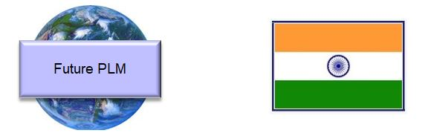
However, there will not be a conflict. The Future PLM Steering Group with global members could have an India sub-committee, or the India Steering Group could integrate as the Future PLM SG eventually forms.

The two key points here are that India is ready to go first, and there are definite benefits in having a Steering Group that is solely focused on India. India can take the lead.

IMPACTING THE MARKET
Industry needs PLM, but industrial companies worldwide can be slow to take it up. In India, as well as the usual failure to see the benefits, there can be regional or state differences that mean a single solution does not work; as well as a tendency just to hire more people to deal with a problem area, rather than understanding the cause and eliminating it.

Companies tend not to want to talk about their failures, or quantify (and therefore reveal) losses that may have occurred. If things already work, even if they are clearly sub-optimal, it is difficult to take them out and replace them.

Impacting the market means changing all of this: making the benefits of PLM crystal clear, across the whole scope of productivity, performance improvement and new technologies in a way that manufacturing companies will listen to and take on board.

This is what the India PLM Steering Group can do, through the vehicle of the PLM 2025-35 Project. It creates awareness in the market, and also shows it how to move forward. With a starting quorum of eight or ten of India’s leading companies, it has credibility with CEOs. The Mobilisation phase starts with the high-level business issues, and produces a Blueprint for them to consider. The Project moves into more detail, and more Blueprints such as how to connect engineering with the shop floor, or how to increase leverage with the Value Chain.

This becomes a steady flow of news. Nothing else like this is happening in PLM, so every time the Steering Group makes progress it becomes the story, not just in India but internationally. And make progress it will – this is a 12-month project, and is the world’s only structured platform for PLM advancement. It publishes new material every month in a continual stream of detail, and eventually everyone will be following it.

The impact goes outside the PLM space, to CEOs and VPs who may not even understand exactly what PLM is. If a vendor or consultancy makes a presentation to explain how PLM will improve engineering or manufacturing performance, then it is just a conventional sales pitch. But if a high-profile Steering Group of companies that the CEO knows and respects publishes the same guidance, it has credibility. Enterprise integration can start.

This is what ‘impacting the market’ really means. The Steering Group is a force for PLM improvement, and it also has traction: and applies that traction over twelve months to achieve the full potential for Indian PLM. It creates a positive flow of mindshift, confidence, success and replication.

The potential impact goes beyond national level. As expertise and best practice comes out into the open, it will become a year-long stream of advanced PLM development and the results will be followed globally. The rest of the world adopts India’s findings and India gets to be front and centre of PLM.

PLM 2025-35 STRUCTURE
It is no good just bringing people together and letting them chat. The Steering Group needs structured working, and levers to pull to ensure that its recommendations are actioned.

This happens because the India PLM Steering Group will be an integral part of the PLM 2025-35 Project structure.

The PLM 2025-35 Project arose from the Professional PLM Initiative last year which highlighted the need for an industry response to the current fractured state of PLM, crystallised into 3 clear objectives:-
- To define the future of PLM over the next 10 years
- To create an internationally-agreed Body of PLM Knowledge
- To establish and prove the best way of implementing AI

The Project has developed a comprehensive working framework that will run for a year initially, aligned with the natural pace of actual PLM implementations and consisting of 3 streams:-
- Future PLM Steering Group to create the Vision and Roadmap
- PLM Body of Knowledge based on real-world User collaboration
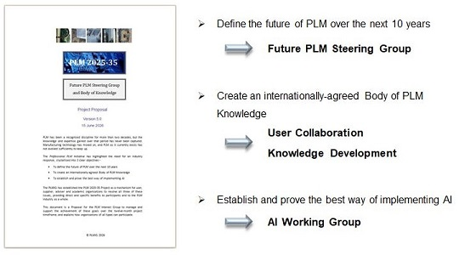
- AI Working Group which will create the definitive PLM-AI model

The India PLM Steering Group operates as an integral part of the first stream, providing guidance and benefitting from the detailed findings from the other streams as they develop in synergy.

METHODOLOGY
The India PLM Steering Group brings experienced practitioners from different organisations and backgrounds together to combine their views on the aims and scope of PLM and to define a new paradigm for India.
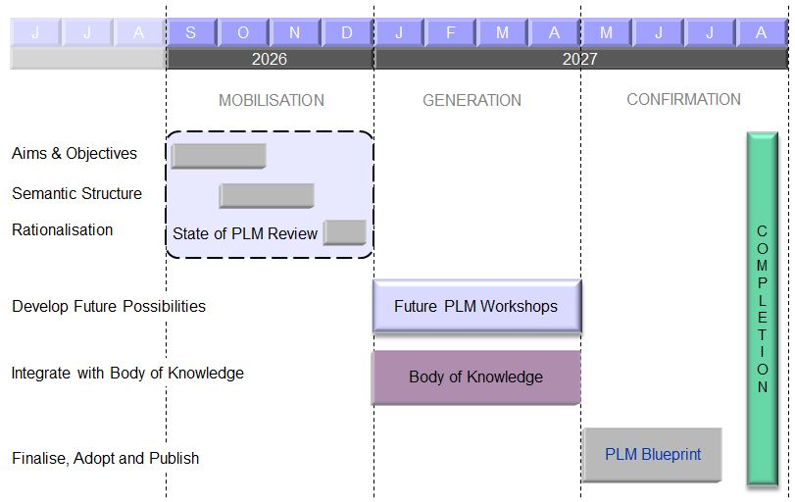
Three streams run in parallel, sharing findings as they progress. There are 3 separate four-month phases:-

Mobilisation
This is essentially a ‘State of PLM Review’, in which SG Members align with each other and organise their thinking. Aims & Objectives are defined, a Semantic Structure is agreed, and Rationalisation sets everyone up for the next phase.

Generation
Generation is where the main work is done. The PLMIG provides the working material and runs concise workshops to Develop Future Possibilities in a formal and structured way, integrated with the detailed work of the Body of Knowledge stream

Confirmation
The new ideas and solutions created during Generation are rationalised and formalised into off-the-shelf working tools and a globally-referenceable knowledge base. The Confirmation Phase also includes direct support for each participant company in completing their own deliverables from the Project.

PLMIG SUPPORT

Management
This is a participatory project, designed to run with a minimum of effort and overhead for the participants. The PLMIG provides the tools and the structure; participants receive the material and join in with the actions at each stage, contributing to the findings; and the PLMIG provides the published results.

Tools
The PLMIG provides all of the tools and working documentation for the project, together with direct support for participants as they are used. In the opening Mobilisation stage these will be bespoke working tools for alignment and definition; and in the ‘Solution Generation’ stage they may include any of the multiple handbooks and manuals that the PLMIG has developed over twenty years.

The PLMIG also sets up and runs the on-line workshops designed to produce the specific problem solutions, and publishes the findings for follow-on use.

Workshops
There will need to be specific working meetings to investigate and analyse the detailed issues that participants want to work on. The PLMIG has extensive experience in running such workshops to produce accurate and useful findings, and the Project members who are interested in each particular issue can take part.

Documentation
In addition to the direct project documentation the PLMIG will produce all of the neutral, ‘distilled’ documentation for the teams in each stream to work on, and will construct the eventual written Body of Knowledge.

Participants in all streams will receive all of the current PLMIG toolsets, and all of the new tools produced during the 12 months of the Project, as part of their Project Membership.

Coordination
Once the mobilisation phase has been completed, PLM Teams from different organisations will be talking to each other in much more detail than has previously been possible. When PLM practitioners get together in this way they generate their own ideas. It is expected that participants may hold local discussions amongst themselves, as part of the general activity of a community. This is to be encouraged, subject to confidentiality, and findings or actions from these interactions can be fed back into the centralised coordination if required.

ADMINISTRATION
PLM 2025-35 is designed to be an informal and flexible project that is easy to be involved with and to benefit from. The Conditions of Participation are therefore minimal:-

1. Companies join the Project. Membership of the Steering Group commences on receipt of the Membership Fee, and will last until the completion of the 12-month project schedule.

The Membership Fee is €8,500 (£7,400, $10,000), which allows an organisation to participate in any or all of the three streams [Future PLM Steering Group, Body of Knowledge and AI Working Group]. Each company can nominate up to 9 people to form their team.

2. User organisations are eligible to join the User Collaboration strand of the Body of Knowledge stream, and if so should be willing and able to participate in its activities. The internal discussions of the UC members are confidential, and any documentation published outside the stream will be neutral and non-attributable. The detailed focus of this half of the project will be decided by its members.

3. Organisations of all types are eligible to join the India PLM Steering Group, the Knowledge Development strand, and the AI Working Group. The internal discussions will be confidential, and the published documentation will be in the proposed neutral format.

4. New Members may join at any time by payment of the same fee, and their membership will run until the completion of the 12-month schedule. It is not expected that the Groups will become so large that they cannot function.

5. No specific practical, financial or legal liability is attached to Project Membership.

6. For the first 12 months (as covered by this Proposal) the Body of Knowledge will be entirely in draft form, with the first release at the end of the project period. The PLMIG and the project members will therefore own it collectively while it is under this development. As publisher, the PLMIG will retain the copyright, and make it available to every project member.

7. At the end of the 12 months the PLMIG and project members will decide whether the Project should continue in its current form, and how the Body of Knowledge should be further developed.

8. PLMIG tools and material, and new material produced by Project activity, are confidential to Members. Participants are encouraged to reproduce, modify, or take extracts from any part of it for their internal use. The PLMIG may compile some of the ongoing draft documentation into new tools which will then become available as part of general PLMIG Membership.

Further information can be requested via steering_group@plmig.com.

https://lnkd.in/exUfcgjE

